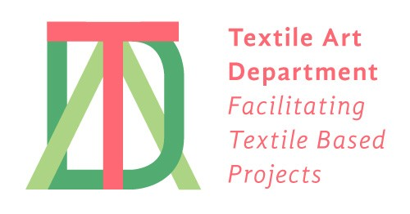
Ruth Scheuing at makerlabs
digitaljacquardweavingstudio@gmail.com
780 East Cordova, Vancouver, BC, V6A 1M3

TAD (Textile Art Department)
Services and Prices
Updated January 2023

Jacquard Loom Rental: $85/day or $50 ½ day; MakerLabs hours access 12-9 pm
Student pricing: available for longer projects

Individual instruction on the Jacquard loom and design: $40/hour

Weaving: We can weave your file and samples @ $24/hour + loom rental + materials;
We provide cost projections for specific project.

Material Costs:
Warp: $8/foot or $25/meter for black or unbleached mercerized cotton 2/10:
2/5 cotton or other set ups: costs + labour

Weft: $7/foot or $22/meter for 20-24” width
$8-10/foot for wider warp and/or thicker yarns and/or multi-weft projects
we stock a wide range of coloured cottons, some linen, wool, hemp and synthetics
or you can supply your own weft yarns.

We work with different warps for our AVL Jacq3G loom, so please enquire.
Currently we use 600 hooks for 20”/50cm with a 2/10 black mercerized cotton @ 30 epi (12 ends/cm).
Max width: 720 hooks/pix; @ 30 epi or 24”/56cm
File size: either 600 or 720 pixel wide

In the past we have used 2/5 mercerized and natural white cotton @ 20 or 24epi for 30-36” width both for a single warp colour and 2 coloured warps

Sewing and finishing: Simple finishing can be provided at cost.

